**Case Management System**

**Introduction**

Welcome to the user documentation for our Case Management system. This comprehensive guide is designed to assist law professionals in effectively utilizing our software to manage and streamline their case-related activities.

Our Case Management system is a powerful tool that enhances efficiency, organization, and collaboration throughout the entire legal process.

With our system, you can efficiently track and manage various aspects of your cases, including client information, documents and deadlines. This user documentation will provide you with step-by-step instructions, tips, and best practices to maximize your productivity and ensure seamless case management.

Whether you are a solo practitioner, a member of a law firm, or part of an in-house law firm team, our Case Management system offers a user-friendly interface, robust features, and customizable options to adapt to your specific needs. From client intake and document management to calendaring and our system encompasses all the essential elements required to handle legal cases efficiently.

This user documentation will guide you through the system’s process, provide an overview of the system's user interface, and offer detailed instructions on how to perform various tasks and utilize different features. Additionally, it will address common troubleshooting scenarios and answer frequently asked questions to help you navigate any challenges that may arise.

**User interface overview**

The user interface (UI) of our Legal Case Management system is designed to provide a user-friendly and intuitive experience, allowing you to efficiently navigate and access the system's features. Here is an overview of the key elements you will encounter within the UI:

Navigation Menu: The navigation menu offers access to different modules and sections of the system. It allows you to switch between key areas such as Manage Cases, Manage Employees, Tasks, and Deadlines.

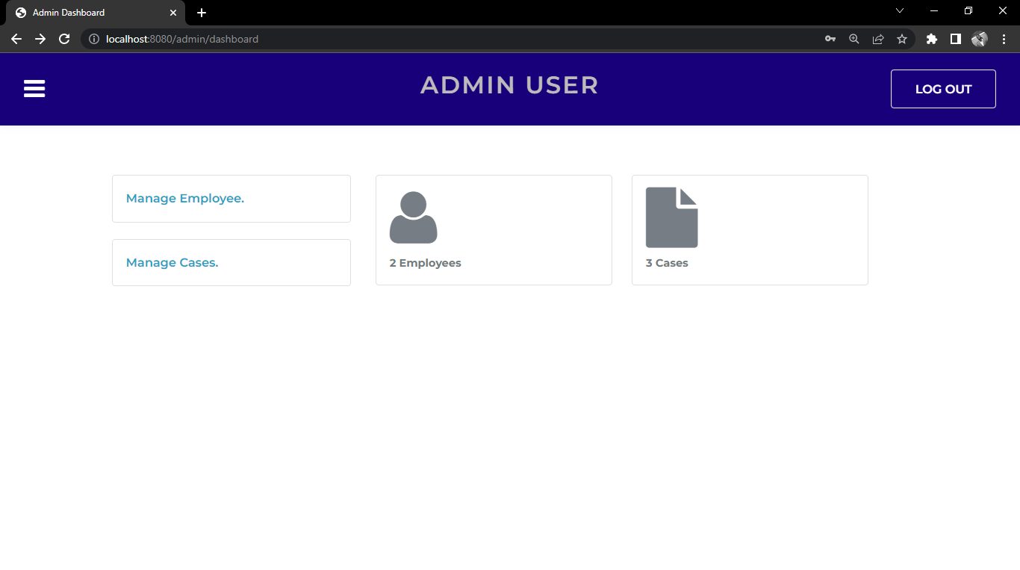

Dashboard: The dashboard serves as a central hub, providing an overview of important information and key metrics related to your cases and tasks. It may include widgets displaying upcoming deadlines, recent activities, task progress, and other relevant data.

Case List: This section displays a list of your active cases, typically in a tabular format. It provides essential details such as case name, case number, assigned attorney, status, and important dates. You can often sort and filter the case list based on various parameters.



Case Details: By selecting a specific case from the case list, you can access detailed information about that case. This includes client details, related documents, case history, notes, assigned tasks, deadlines, and other relevant data.

Client Management: The system includes features to manage client information effectively. This may involve creating new client profiles, storing contact details, tracking client communications, and associating clients with their respective cases.

Document Management: A dedicated section allows you to upload, organize, and manage case-related documents. You can create folders or categories, apply tags or labels, and search for specific documents based on different criteria.

Calendar and Tasks: The system integrates a calendar to manage important dates, deadlines, court appearances, and meetings. It may also include a task management feature, enabling you to create, assign, and track tasks associated with each case.

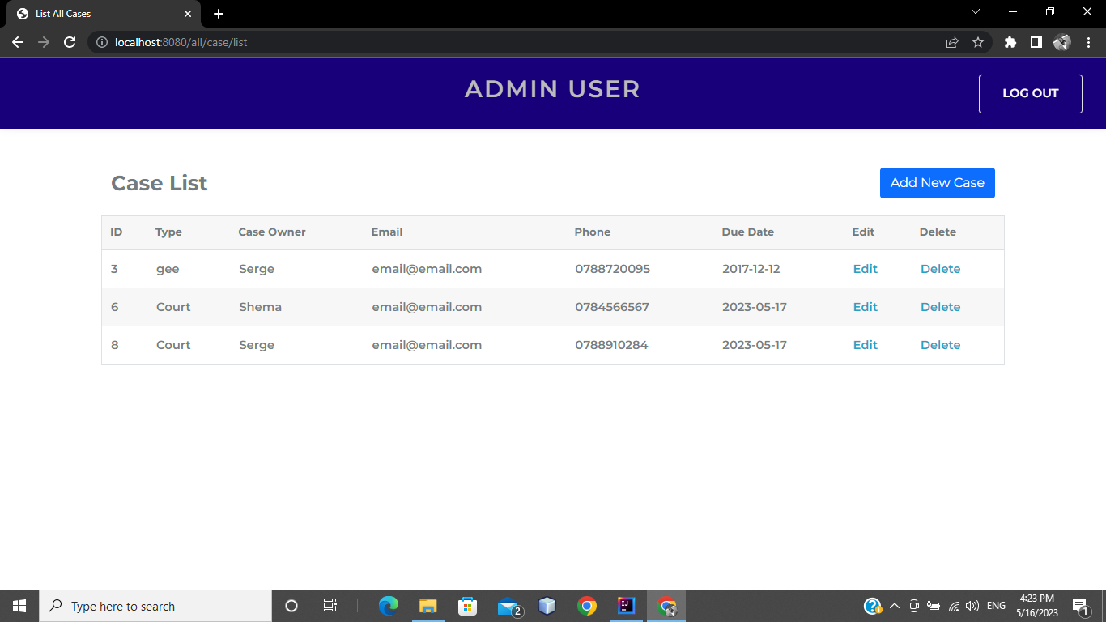

Throughout the user interface, you will commonly find buttons, icons, and dropdown menus that provide additional functionality or options. These elements are typically labeled or accompanied by tooltips to help you understand their purpose.

**Reminder**

This user interface may vary slightly based on the specific version or customization of the Legal Case Management system you are using. However, the general principles and features mentioned here should provide you with a solid understanding of navigating and utilizing the system effectively.

**Getting Started Guide**

This getting started guide will walk you through the essential tasks and workflows in our Legal Case Management system. By following these step-by-step instructions, you will quickly become proficient in using the system to manage your legal cases effectively.

Logging In

* Open your preferred web browser and navigate to the login page of our Legal Case Management system.
* Enter your username and password provided by your system administrator.
* Click the "Login" button to access the system.
* If you are the Admin create a username and a password for each lawyer to access the platform.

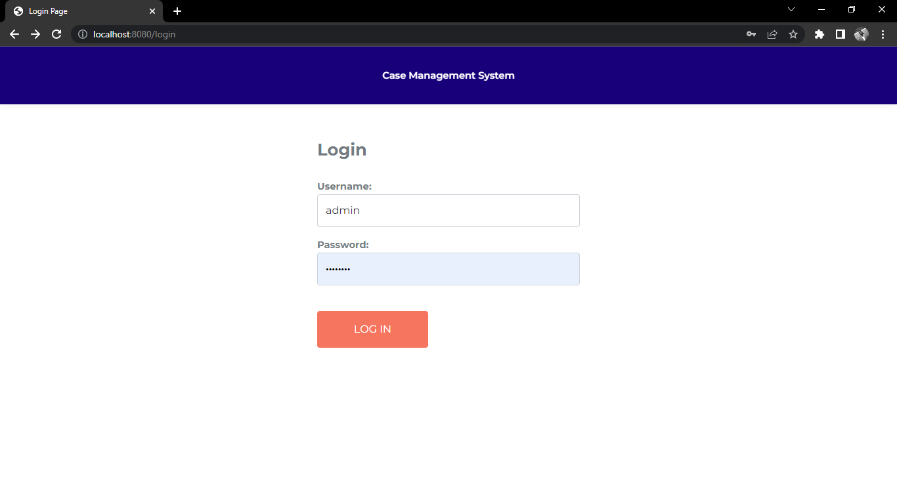

Navigating the Dashboard

* Upon logging in, you will be directed to the dashboard, which provides an overview of your active cases and other relevant information such as number of cases and Employees.
* Take a moment to familiarize yourself with the widgets and sections on the dashboard.
* Click on the different links and buttons to explore the functionality available directly from the dashboard.



Creating a New Case

* From the navigation menu, select the "Manage Cases" option.
* Click on the "New Case" button to initiate the case creation process.
* Enter the required information, such as case owner’s name, other client details, case type, and any other relevant data.
* Save the case record.



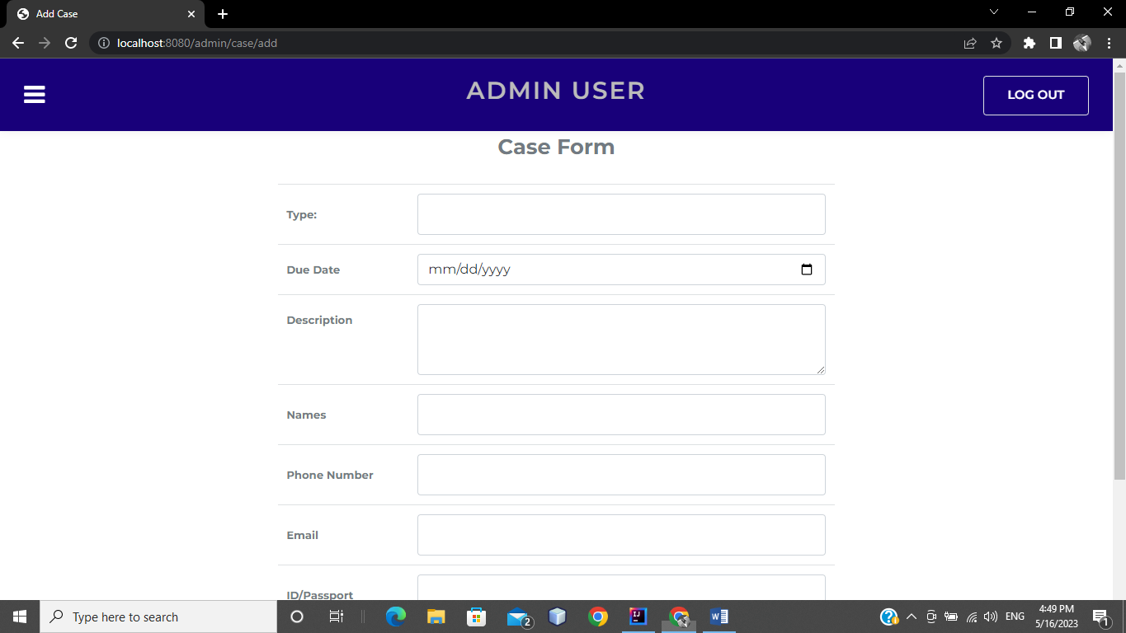

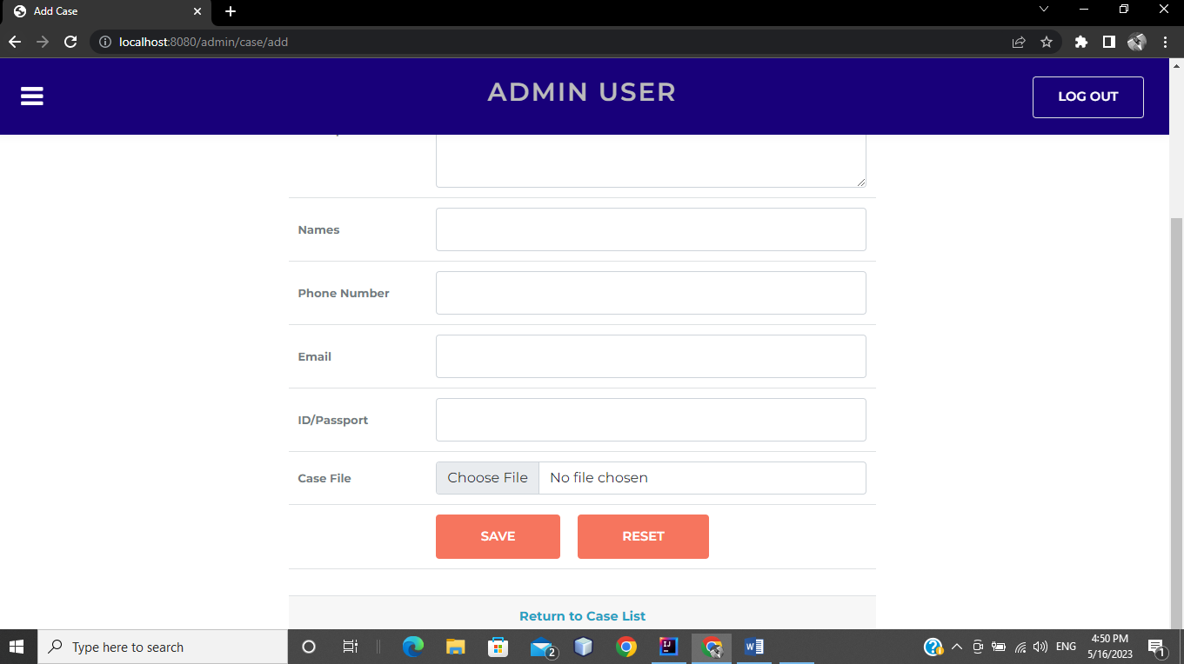

Managing Case Details

* Locate the newly created case in the case list.
* Edit or update case details as necessary.
* Add case notes to track important information or developments related to the case.
* You are also able to delete the case if you want to.

Uploading Documents

* Access the case details page of the desired case.
* Navigate to the "Documents" section.
* Click on the "Upload Document" button.
* Select the document file from your computer and provide a brief description or title.
* Save the document to associate it with the case.



Managing Tasks

* Go to the Case List page.
* Locate the "Edit" button.
* Click on the "Edit" button.
* Enter task details, including the task description, assignee, due date, and priority.
* Save the task to add it to the case's task list.



Managing Clients

* Click on the "Edit" button.
* Enter the client's contact information, such as name, address, email, and phone number.
* Save the client record.
* Associate the client with relevant cases by linking them in the case details.



Managing Employees

* Click on the "Edit" button.
* Enter the client's contact information, such as name, address, email, and phone number.
* Save the client record.
* Associate the client with relevant cases by linking them in the case details.

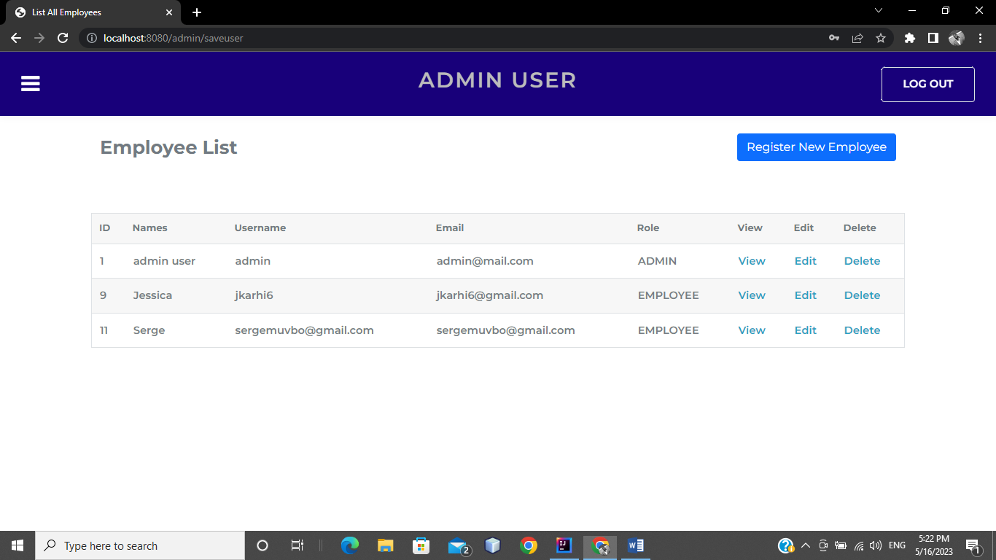

These steps cover some of the fundamental tasks and workflows in our Legal Case Management system. The user documentation will provide more detailed instructions and additional features to help you maximize your productivity and effectively manage your legal cases.

Troubleshooting

System Login Issues:

* Double-check your username and password for accuracy.
* Ensure that you have a stable internet connection.
* Clear your browser cache and cookies, then try logging in again, contact your system administrator if the issue persists.

Document Upload Problems:

* Check the file format and size requirements. Ensure that you are uploading supported file types within the size limit.
* Verify that you have proper permissions to upload documents.
* If encountering errors, try uploading the document again or consider using an alternative browser.
* Contact support if the problem persists or if you suspect a technical issue.

Task Assignment or Completion Issues:

* Confirm that you have the necessary permissions to assign tasks or mark them as complete.
* Ensure that you are selecting the correct assignee and setting appropriate due dates.
* If tasks are not updating as completed, refresh the page or try logging out and logging back in.
* Contact the system administrator if the issue persists or if there are any inconsistencies.

Frequently Asked Questions (FAQs)

How do I create a new case?

From the navigation menu, select "Cases" and click on the "New Case" button. Fill in the required information, such as case name, client details, and case type, then save the case.

How can I upload documents to a case?

* Navigate to the specific case details page, go to the "Documents" section, and click on the "Upload Document" button.
* Choose the document file from your computer, provide a brief description, and save the document.

How do I edit client information?

From the navigation menu, choose "Clients" and locate the client you want to edit. Click on the client's name to access the details page, make the necessary changes, and save the updated information.

These FAQs provide brief answers to common questions. For more detailed instructions or additional FAQs, refer to the user documentation or contact the support team for assistance.